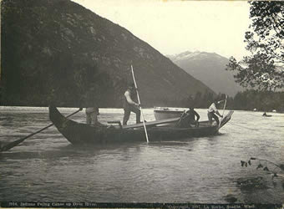 Building Numeracy, Literacy, and Core Competencies through construction of a Skin Boat

View Video: The last Moose skin Boat from National Film Board before doing the activity: https://www.nfb.ca/film/last_mooseskin_boat/

Possible Learning Targets (grades 9-10)

English Standards
- I can connect the purpose of story in recognizing how oral language reflects personal and cultural identities
Mathematics Standards
- I can use thinking strategies and estimation, to calculate volume of a model skin boat
- I can include Yukon First Nations ways of knowing and doing and use proportional reasoning to determine the volume of an adult sized skin boat, when given the ratios.
- I can develop a budget to determine the costs of making a skin boat.
Science Standards
- I can construct a model skin boat from materials in nature and describe how each piece of material demonstrates interconnectedness among Yukon First Nations ways of knowing and doing.

Connect to Learning Standards for your students. How can this activity help achieve learning standards for your students? (Create learning targets here)

Given the following materials, your group is tasked to build a model skin boat. Use the pictures and the model given to guide your thinking. Consider the following discussions questions before you began to build:

- Think about how you can work together to build the model (who should do what job)
- Think about how you can us the materials with little waste
- Think about properties in a skin boat that would be important (size, volume, strength) and how you can utilize the materials to meet those properties.

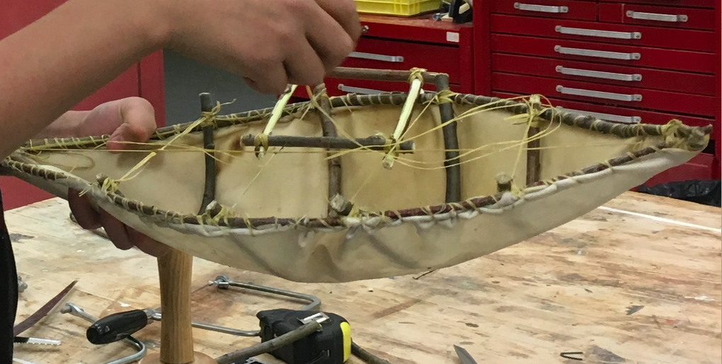Skinboat made by a Ross River Student

Materials: Use any or all of the given materials

- Deer hide
- willow branches
- Synthetic sinew
- Scissors and knife
- Thimble
- Pliers
- Hide needles (circular or straight)

Task: Collaboratively build a model skin boat

Reflection Questions:

How can this activity help students build Literacy and Numeracy skills?

Numeracy:

Literacy:

How did this activity fit into each of the Core Competencies?

